Humanitarian project
Health care institution Petrikovskaya central regional hospital
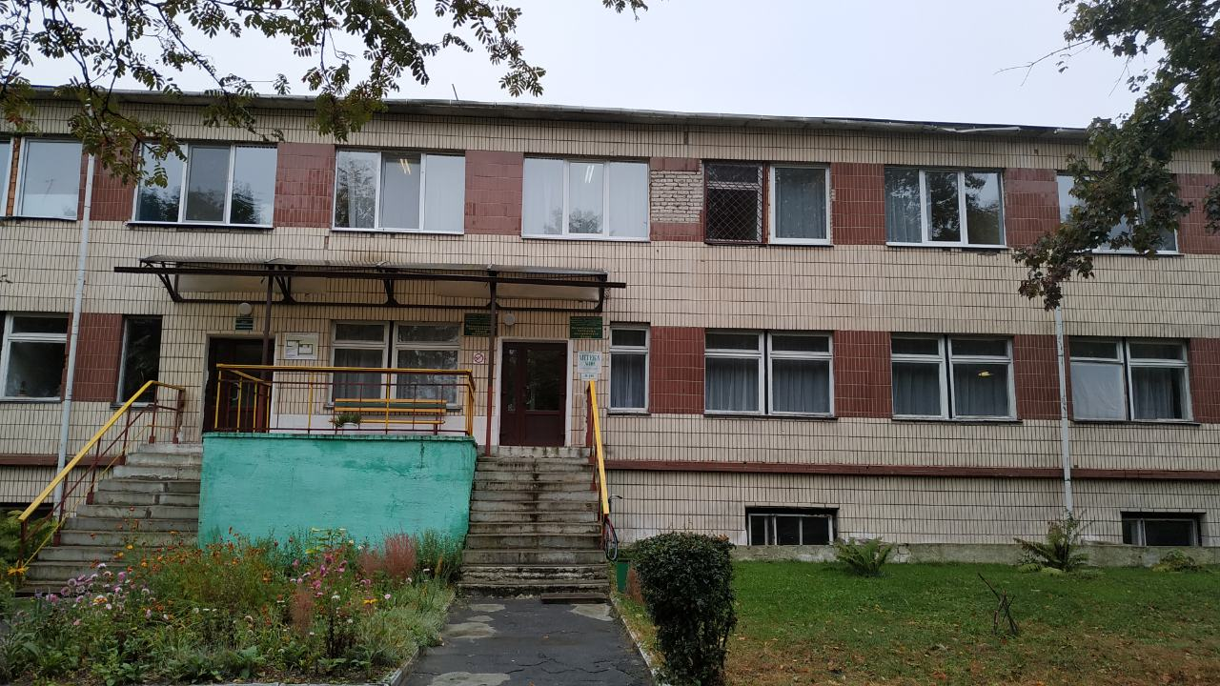
1. | Name of the project | "Old age in joy"
2. | Name of company | Healthcare institution "Petrikovskaya central regional hospital"
3. | Physical and legal address of the organization, phone, fax, e-mail | Republic of Belarus Gomel region Petrikovsky district Petrikov st. Lunacharsky, 5  phone +37523502-82-08  Email address : petrikov.gomel-region.by;  petrtmo@mail.gomel.by
4. | Organization information | UZ "Petrikovskaya CRH" traces its history since 1914.  The first mention of medical institutions on the territory of Petrikovshchina dates back to 1914. Since 1919, in the town of Petrikov there was a Soviet hospital, which was located in the building of a former military warehouse, which included 3 buildings ... The hospital was designed for 30 beds. The hospital employed 3 doctors, 2 paramedics, 22 technical personnel, the head of the Soviet hospital was Mikhail Adamovich Rutkovsky.  ... Today, the hospital has become the center of a wide network of medical and preventive institutions in the region, district hospitals, outpatient clinics and feldsher-obstetric centers are operating, specialized types of medical care are being developed
5. | Head of the organization | O. L. Semikopenko, chief physician, "Petrikovskaya CRH"  +37523502-82-08
6. | Project manager | O. L. Semikopenko, chief physician, "Petrikovskaya CRH"  +37523502-82-08
7. | Previous aid received from other foreign sources | The health care institution "Petrikovskaya CRH" did not receive any assistance from other foreign sources.
8. | Amount required | 320 000.00 ( US dollars )
9. | Co-financing | All sponsor funds
10. | Project term | 2021-2022year
11. | Objective of the project | Creation of favorable conditions for elderly and senile people, centenarians and disabled people suffering from chronic diseases, in need of medical supervision and care and for health reasons in need of treatment.
12. | Project objectives | - collection of funds for the current repair of the building and premises (social post department, catering, laundry, etc.)  - collection of funds for the purchase of furniture and equipment (beds, wheelchairs, wheelchairs, walkers, walking sticks, bedding, etc.)
13. | Detailed description of the activities within the project in accordance with the tasks set | Novoselkovsk hospital for nursing care founded in 1978, nursing beds - 25  Those in need of medical and social assistance from their area find themselves in nursing beds.  Brief description of project activities:  - current repair of the catering unit with replacement of equipment and exhaust ventilation  - ongoing repair of the dental office  -repair of the outpatient clinic, 1st floor  - ongoing repair of ambulance, furniture replacement  - ongoing repair of the laundry, replacement of equipment  Target group: elderly people  Responsible person: O. L. Semikopenko Chief Physician of the Petrikov Central District Hospital
14. | Justification of the project | 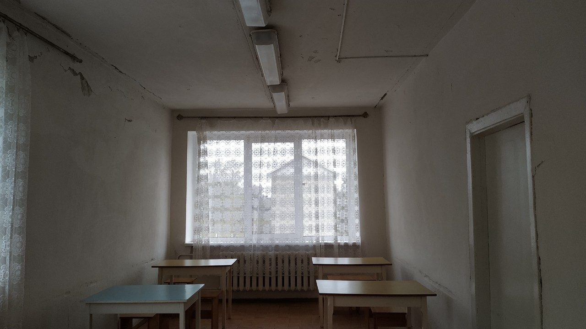  This is what the dining room looks like at the moment.  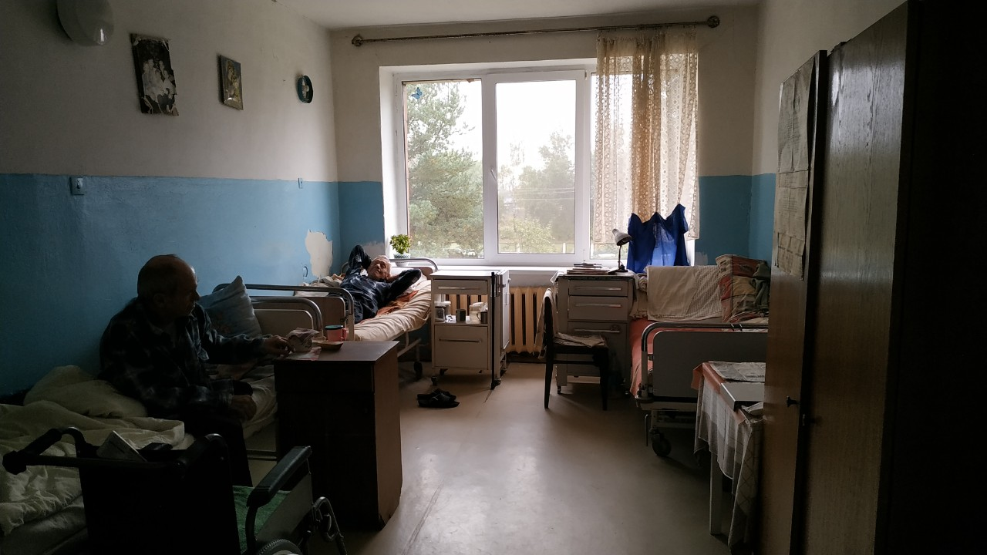  It looks like a ward where the elderly are  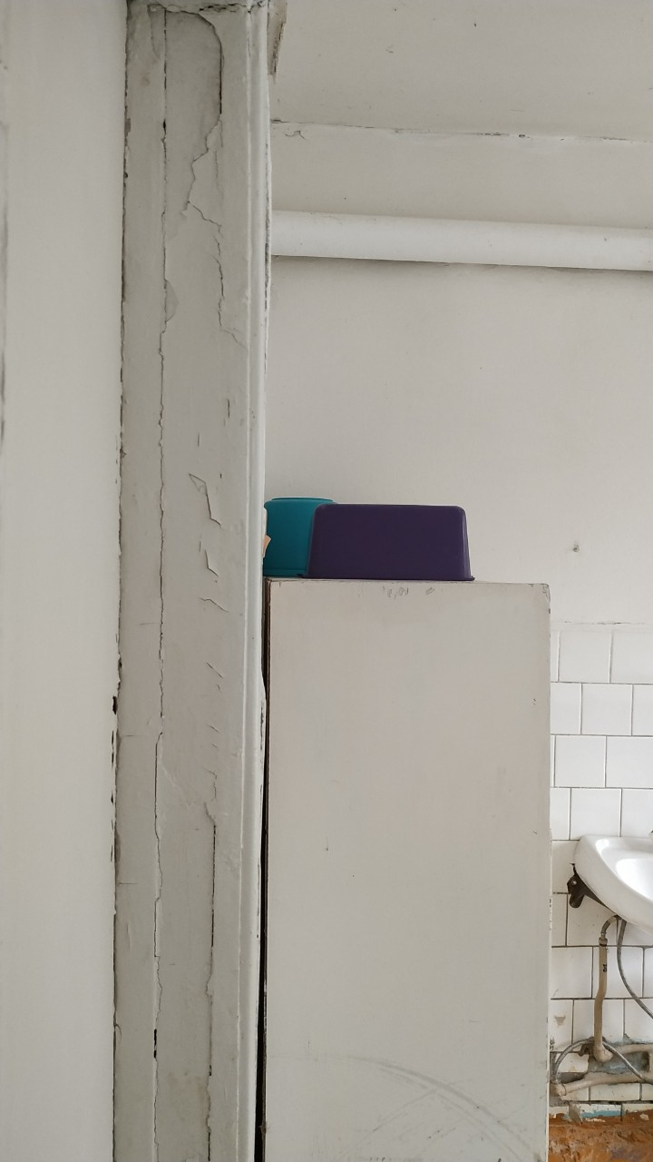  The presented photos show the depressing state of the Novoselkovsk hospital for nursing .
15. | Post-project activities | The nursing hospital provides medical and social assistance to elderly and senile people, centenarians and disabled people suffering from chronic diseases, in need of medical supervision and care and for health reasons in need of treatment.  The hospital in accordance with the tasks assigned to it  performs the following functions:  - conducting weekly examinations of patients by the chief physician of the hospital and prescribing the necessary measures for the provision of medical and social assistance, a complex of symptomatic therapy and methods of physical rehabilitation;  - organization of rational nutrition, including  dietary, in accordance with medical recommendations;  - referral of patients to other health care organizations  to provide specialized medical care for conditions requiring urgent medical intervention by specialist doctors;  - implementation by nursing staff:  - round-the-clock medical monitoring of the patient's health and taking measures aimed at preventing the exacerbation of chronic diseases in them;  - medical care of patients, including conducting their daily examination;  - moral and psychological support for patients; - feeding weakened patients; -medical procedures (measuring body temperature, blood pressure, applying compresses, dressing, treating pressure sores, performing cleansing enemas, etc.); -primary health care in case of deterioration of the patient's health;  - a complex of symptomatic therapy and methods of physical rehabilitation for patients as prescribed by the chief physician;  -performing other measures for the provision of medical and social assistance, appointed by the chief doctor of the hospital.  This is how I would like to see the ward after renovation  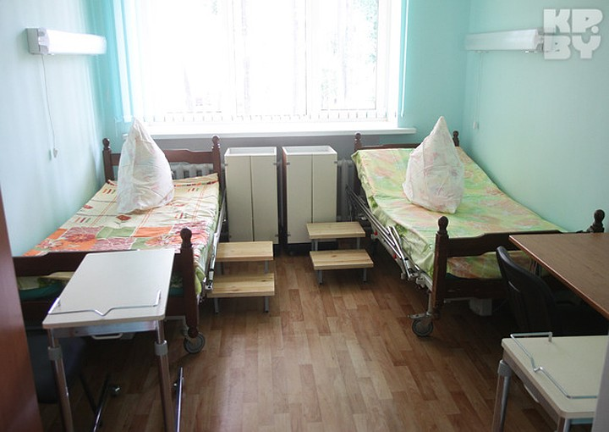  Dining room  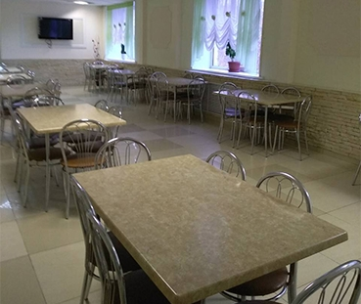
16. | Project's budget | 320 000.00 ( US dollars)

