Humanitarian project
Health care institution Petrikovskaya central district hospital

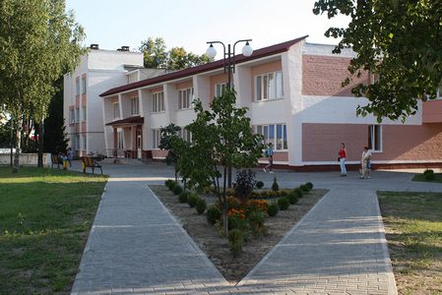
1. | Name of the project | "Let's save life together"
2. | Name of company | Health care institution "Petrikov Central District Hospital"
3. | Physical and legal address of the organization, phone, fax, e-mail | Republic of Belarus Gomel region Petrikovsky district Petrikov st. Lunacharsky, 5  phone + 37523502-82-08  Email address : petrikov.gomel-region.by  petrtmo@mail.gomel.by
4. | Organization information | UZ "Petrikovskaya CRH" traces its history since 1914.  The first mention of medical institutions on the territory of Petrikovshchina dates back to 1914. Since 1919, in the town of Petrikov, there was a Soviet hospital, which was located in the building of a former military warehouse, which included 3 buildings. The hospital was designed for 30 beds. The hospital employed 3 doctors, 2 paramedics, 22 technical personnel, the head of the Soviet hospital was Mikhail Adamovich Rutkovsky. Today, the hospital has become the center of a wide network of medical and preventive institutions in the region, district hospitals, outpatient clinics and feldsher-obstetric centers are operating, specialized types of medical care are being developed
5. | Head of the organization | O. L. Semikopenko, chief physician, "Petrikovskaya CRH"  +37523502-82-08
6. | Project manager | O. L. Semikopenko, chief physician, "Petrikovskaya CRH"  +37523502-82-08
7. | Previous aid received from other foreign sources | The health care institution "Petrikovskaya CRH" did not receive any assistance from other foreign sources.
8. | Amount required | 460000 ( thousand US dollars)
9. | Co-financing | All sponsor funds
10. | Project term | 2020-2021 year
11. | Objective of the project | -timely diagnostics of diseases using computed tomography, as one of the leading methods of diagnosing diseases, allowing to identify pathological changes at the earliest stage;  - improving the quality and availability of medical care;  - the correct choice of treatment tactics;  - preserving the life and health of residents and guests of the Petrikovsky district  .
12. | Project objectives | -creation of a computed tomography room in the hospital area;  - installation of a computed tomograph;
13. | A detailed description of the activities within the project in accordance with the assigned tasks | - purchase of a computer tomograph  -training of medical personnel  Target group: population of Petrikovsky district, as well as residents of nearby areas, guests.  Responsible person: O. L. Semikopenko, chief physician of the Petrikovskaya CRH
14. | Justification of the project | - project preparation;  - carrying out construction and installation works;  - carrying out the procedure for the purchase of medical equipment;  - equipment installation;  - training of medical personnel  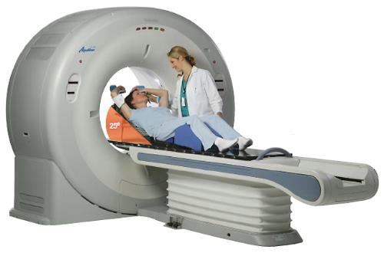  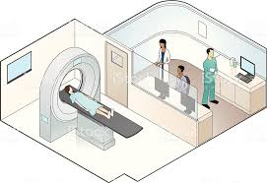
15. | Post-project activities | After the end of the project, residents of the district will be able to undergo examination for the early diagnosis of acute cerebrovascular accidents, traumatic brain injuries and other diseases of the brain. The medical effect is the promptness of the diagnosis of cerebrovascular diseases and traumatic brain injury, the timely implementation of therapeutic measures, the prevention of disability and mortality.
16. | Project's budget | 460000,00 ( thousand US dollars)

